**CS 344 Problem Set 1: Asymptotics**

Kanghwi Lee

1. If f(n) = o(g(n)) and g(n) = o(h(n)), we need to show that there exist the cost. C and no such that

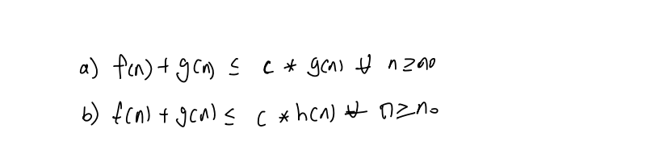

Since f (n) = O (log n) there exist the cost c1 and n1 such that



Similarly g(n) = O (h(n)) there enlist the cost c2 and n2 such that



